[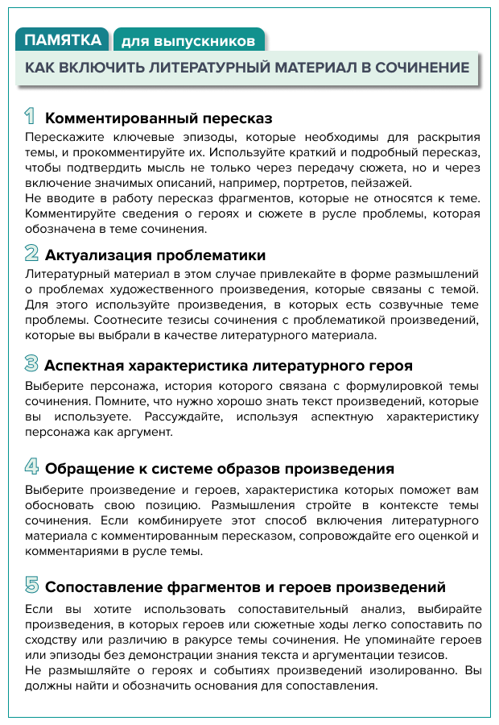](https://vip.1zavuch.ru/?utm_medium=letter&utm_source=letter_demo&utm_campaign=letter_demo_2021.11.04_esz_activedemo_04112021&utm_content=7079678&btx=7079678&mailsys=ss&token=35ea6bf0-bcaa-11a0-bf72-2d01a4b6531a&ttl=7776000&ustp=F)